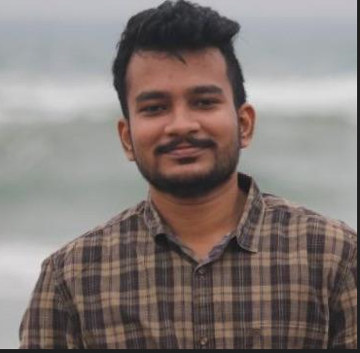 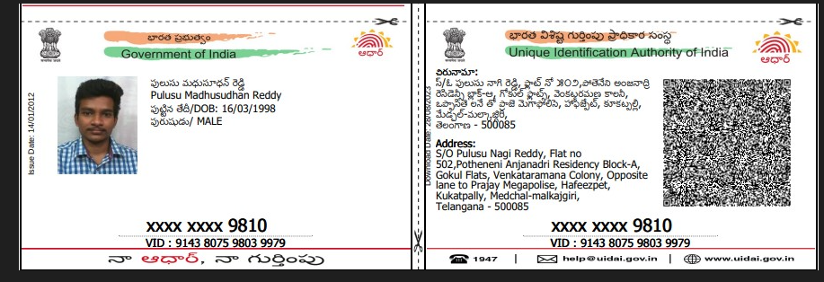 MADHUSUDHAN REDDY PULUSU DATA ENGINEER
madhupand44@gmail.com| +91-8019957064 | https://www.linkedin.com/in/madhu-sudhan-reddy-p/

Vedio link : Madhusudhan Reddy _ Interview _ Data Platform engineer-20230901_013133-Meeting Recording.mp4

Skills
Python| Scala | Azure| Spark | Databricks |SǪL | ETL | API | Kafka| Git| Azure DevOps| Flask| AWS| Spark Streaming| Flink| Machine Learning

Work Experience

Tiger Analytics| Data Engineer – Bigdata, Azure May’21 – Present (2+ Years)

- Working as a Data Engineer for a renowned CPG client, to build an omnichannel data infrastructure on Azure
- I am responsible for ingesting sales, marketing, and advertising data from Amazon, Shopify, and other digital commerce platforms and brick-and-mortar stores onto the lake.
- Working closely with data scientists to harmonize data from various external data sources and making the data available to perform advanced analytics.
- Built an Ingestion framework to solve data catalog, data discovery, and lineage tracking problems on top of the traditional data lake.
- Creating automated workflows and pipelines using ADF, Airflow, and Databricks.
- Created a framework to efficiently handle PII data as per GDPR and CCPA standards.
- Data Modeling and implementation of lake house architecture using Delta and Databricks.
- Created a reusable ETL framework, that helps to maintain the state of the pipelines, thus making pipelines robust and high fault-tolerant.
- Built a Data Profiler and Data Ǫuality modules to check for data drifts.
- Reduced cloud costs by 30% by re-evaluating the architecture and services.
- Spark performance tuning for optimal query performance.
- Created a Synapse custom connector for Airflow.
- Created a framework for data de-duplication for a use case on Customer entity resolution using Machine learning on Spark ML.
- Created Azure DevOps Pipelines to deploy ADF, Databricks, SǪL queries, and Function Apps in multiple environments.

Virtusa| Associate Software Engineer (Python & Bigdata) May’19 - May’21 (2 Years)

- Worked as a developer in a team to build a Web-based data Ǫuality and comparison engine for one of the largest retail banks.
- Implemented the Project End to End in Agile Scrum model following TDD approach.
- Lead the team with requirements gathering and solution design.
- Performed data wrangling and analysis using pandas and PySpark.
- Built Metadata and Reporting services on Python, Flask.
- Designed Data Model on Oracle & SǪLite.
- Implemented Data Ǫuality and Comparison Engine from scratch in Python and Scaled the application to Spark using Scala.
- Created a Cardinality service to validate data quality for multi-dimensional datasets on spark.
- Built flask restful microservices API to integrate with different services.
- Implemented Custom pipelines for CI/CD pipeline using (Git, Jenkins, SonarǪube, RLM).
- Built Automated scripts to deploy application on Docker and Open shift

Certifications
- Databricks Certified Data Engineer Professional
- Microsoft Certified: Azure Data Engineer Associate
- Astronomer Certification DAG Authoring for Apache Airflow
- AWS Solutions Architect Associate
- Talend Certified Data Integration Developer

Projects
Track and Trace, Supply chain management tool Jan’19
  - Technology used: Blockchain using Hyperledger, Angular
  - Description: Developed a Web Application that provides Customers, Manufacturers, Retail Stores a platform to Track their products and trace their route and it also provides them a single Unified Inventory Management System, so that manufacturers and retail stores need not have a separate POS Software and avoid product counterfeits.

Education
MLR Institute of Technology, Hyderabad, India 2015 - 2019
Computer Science and Engineering| CGPA: 8

Interests
- Travelling
- Video Games

